**Props stand for properties**

**These are used as the parameters of the function**

**First we will create a file and import it into App.js file ↓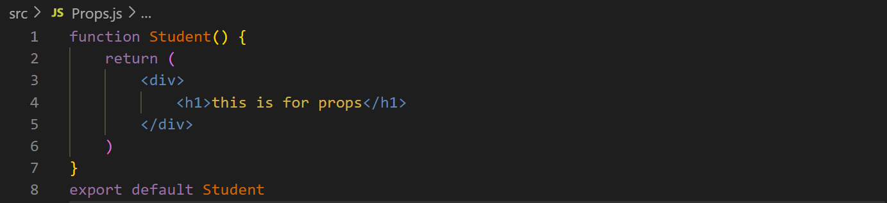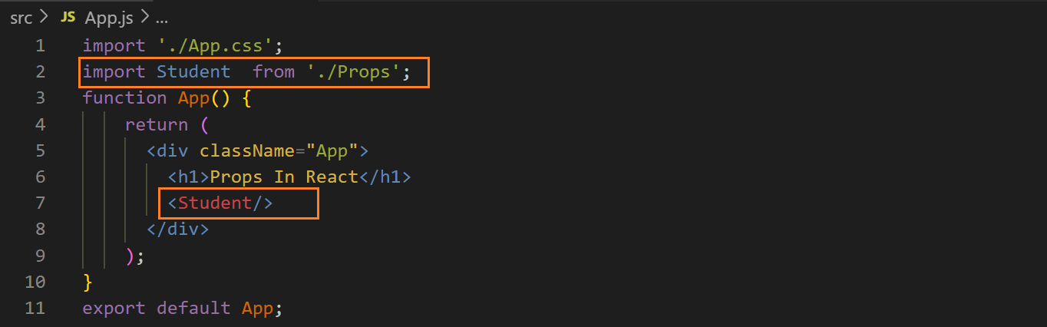output ↓**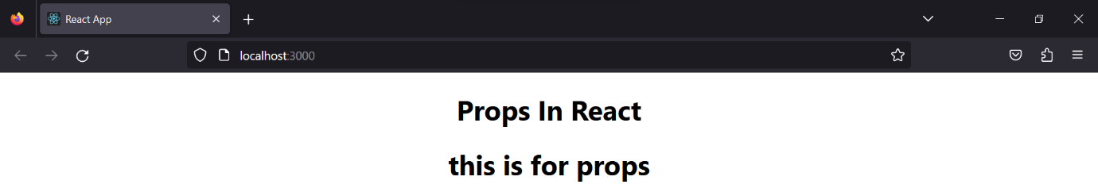

**declare variables in <Student/> with a value in {} and pass a prop in the function and the variables with the help of the prop ↓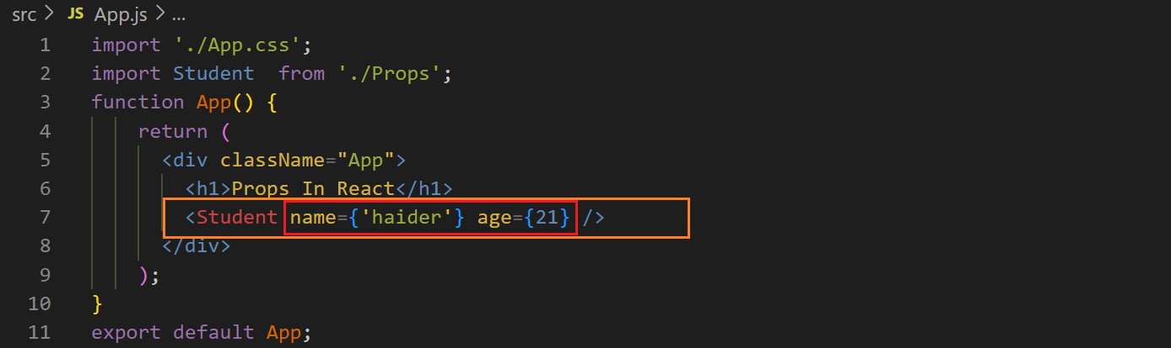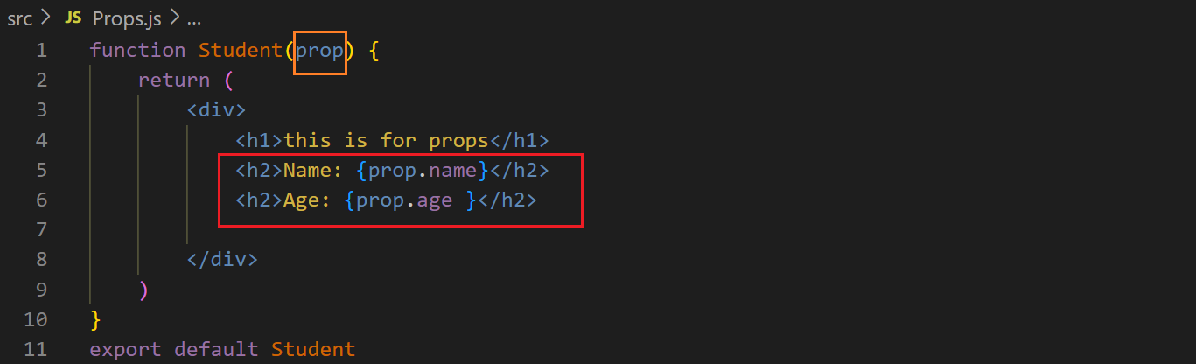 output ↓**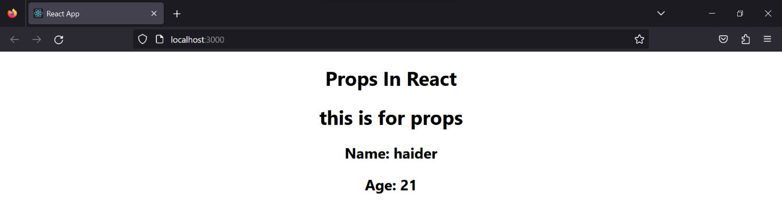

**We can pass multiple props for different students ↓**

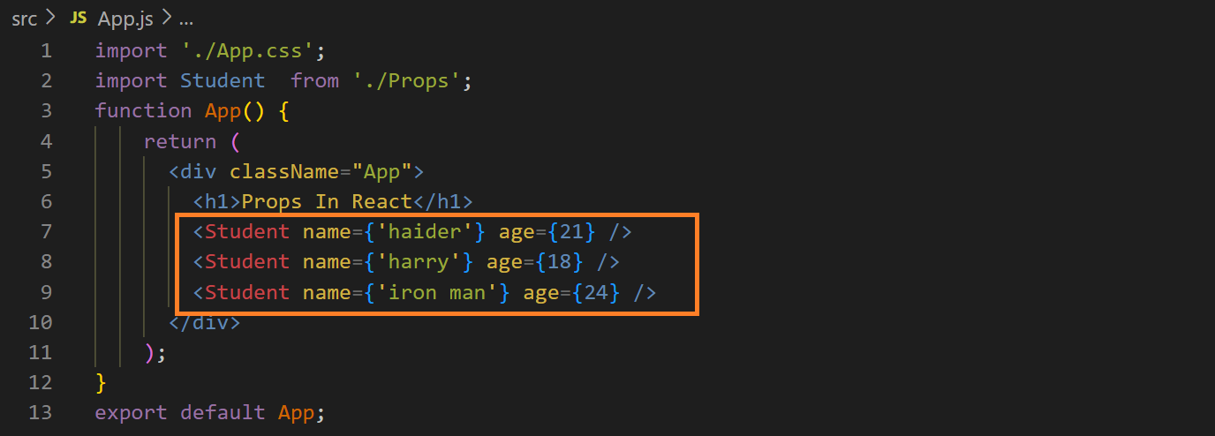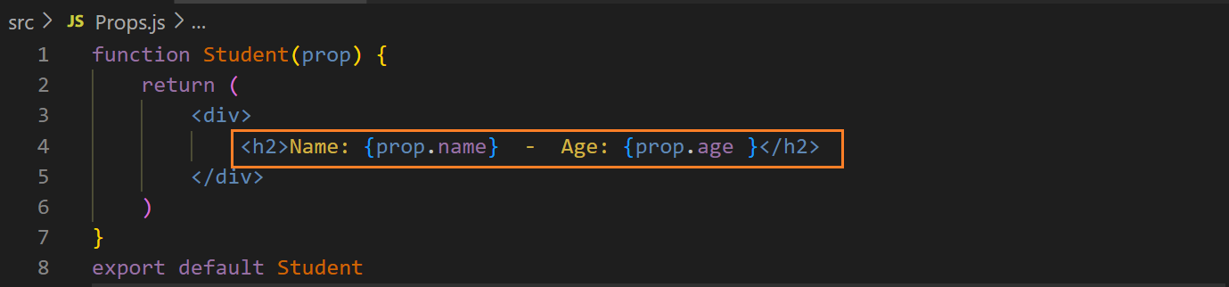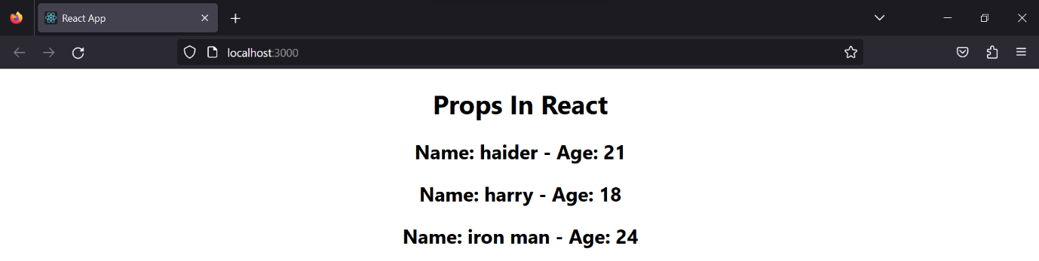

**Other examples ↓**

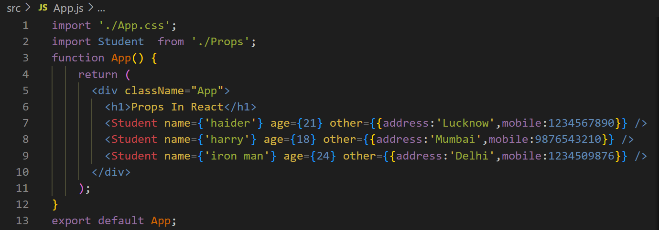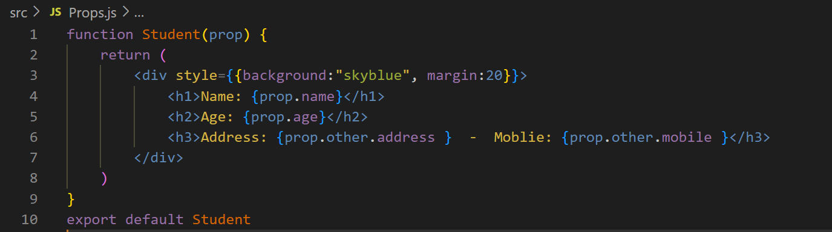

**Output ↓**